# List of Experiment:

C and C++

1. Write a C program to print the address of a variable using a pointer.
2. Write a C program to create a Calculator using a pointer.
3. Write a C program to swap the two values using call by value and call by reference.
4. Define a structure type struct personal that would contain person name, Date of birth and age using this structure to read this information of 4 people and display the same.
5. Write a C program to calculate the sum of n numbers entered by the user using dynamic memory allocation.
6. A file named “New” contains a series of integer numbers. Write a c program to read all numbers from a file and then copy all odd numbers into a file named “odd” and write all even numbers into a file named “even”. Then display the values of files odd and even on the screen.
7. Write a C++ program to Check if the number is prime or not using a function.
8. Write a C++ program that prompts the user to enter a letter and check whether a letter is a vowel or constant.
9. Write a C++ program to demonstrate the concept of constructor and destructor.
10. Create a class student that stores roll_no, name. Create a class test that stores marks obtained in five subjects. Class result derived from student and test contains the total marks and percentage obtained in test. Input and display information of a student.
11. Write a C++ program to overload binary + operator.
12. Create a base class called 'SHAPE' having two data members of type double, member function get_data( ) to initialize base class data members, pure virtual member function display_area( ) to compute and display the area of the geometrical object. Derive two specific classes 'TRIANGLE' and 'RECTANGLE' from the base class. Using these three classes design a program that will accept dimension of a triangle / rectangle interactively and display the area.

DBMS

1. To study DDL-create and DML-insert commands.
2. Create tables and insert sample data in tables.
3. Write the SQL queries to provide constraints on given tables.
4. Write the SQL queries to perform various aggregate functions on table data.
5. Write the SQL queries to perform numeric,date and String functions.

HTML, CSS and JS:

1. Make a Resume using the HTML tags without CSS.
2. Create an HTML webpage that shows Poster Presentation using all Table Properties.
3. Create an HTML page table and form.
4. Create Registration form and do proper validation with HTML 5 inbuilt functionality. (Don’t use JavaScript).
5. Make a Resume using the HTML tags with CSS.
6. Create an HTML Page containing the following Gray Layout using CSS.

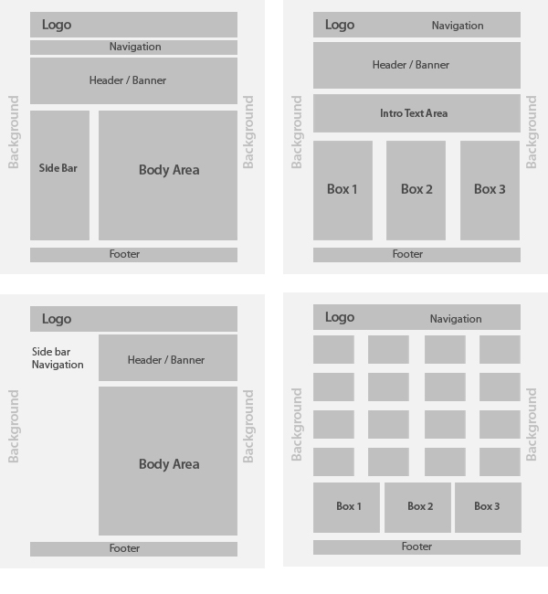

1. Demonstrate JavaScript Form Validation with proper examples.
2. Write a javascript to check if the number is even or odd.
3. Create a page and access the LocationAPI.
4. Create a simple XMLHTTPRequest,and retrieve the data from the text file.